
Amazon Interview Worksheet
DELIVER RESULTS
Definition and Indicators
Deliver Results: Leaders focus on the key inputs for their business and deliver them with the right quality and in a timely fashion. Despite setbacks, they rise to the occasion and never settle.
What this looks like in Practice
As a people manager do you… | As an individual contributor do you…
- Continually reinforce to yourself and the team who the customer is in order to execute and deliver the right results?
- Set and communicate smart team goals, expectations and priorities; help employees stay focused, yet nimble and adaptable to moving targets or when projects aren’t progressing in order to get things done?  - Help others remove barriers/roadblocks towards meeting team goals?  - Recognize and celebrate successes, while keeping the team focused on delivering the right results? | - Focus on the most important tasks, while adapting as needed to achieve results?  - Persevere through setbacks and overcome obstacles to deliver outstanding results?

Deliver Results - Suggested Behavioral Interview Questions
For each question you choose, use a separate STAR Worksheet
Questions for (Manager) in parentheses

- Tell me about a time you (and your team if Manager) were driving toward a goal and were more than half way to the objective when you realized it may not be the best or right goal or may have unintended consequences. What was the situation and what did you do? [testing for achieving the right result versus driving goal for sake of goal achievement. May want follow up questions regarding to determine if the person was willing to take hit on goal attainment to achieve the right result and test long term versus short term thinking.]
- Tell me about a goal that you set that took a long time to achieve or that you are still working towards. How do you keep focused on the goal given the other priorities you have?
- Tell me about a time where you not only met a goal but considerably exceeded expectations. How were you able to do it? What challenges did you have to overcome?
- Give me an example of a time when you were able to deliver an important project under a tight deadline. What sacrifices did you have to make to meet the deadline? How did they impact the final deliverables?
- Tell me about a time you had significant, unanticipated obstacles to overcome in achieving a key goal. Were you eventually successful?
- How do you ensure you are focusing on the right deliverables when you have several competing priorities? Tell me about a time when you did not effectively manage your projects and something fell through the cracks. (Manager)
- What’s your secret to success in setting stretch goals for your team that are challenging, yet achievable? Tell me about a time you didn’t hit the right balance. How did you adjust? (Manager)
- Give an example of a mission or goal you didn’t think was achievable. What was it and how did you help your team try to achieve it. Were you successful in the end? (Manager)
STAR WORKSHEET
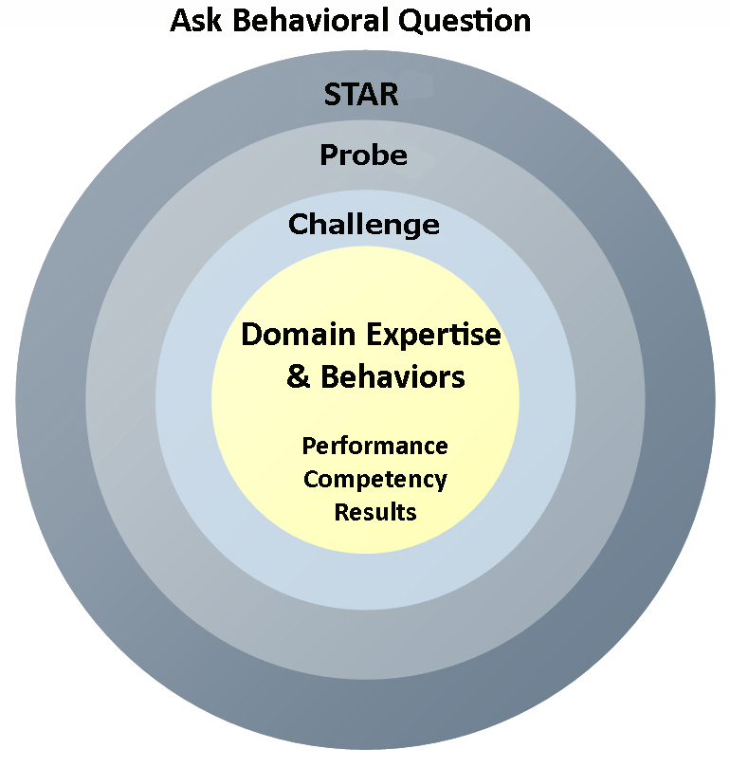
Your Behavioral Question:___________________________________________________________________Leadership Principle:_________________

- Choose behavioral question that provoke specific examples or stories for your assigned Leadership Principle(s).
- Process the example using STAR. Stories have beginnings (Situation/Task), middles (Actions) and ends (Results).
- Once you have established the story, PROBE to dive deeper on your assigned competency (Leadership Principle), get clarity or pursue a concern.
- If appropriate, CHALLENGE the candidate’s statements, decisions or thought process.
S  T | SITUATION/TASK - Describe the situation/task you faced and the context of the story  Answers the questions: where did this occur, when did it happen, why is it important?  Probing Questions:  - Why is this important? What was the goal?  - What was the initial scope of the project? What were the challenges?  - What were the risks and potential consequences if nothing happened?  Challenge Questions:  - Why did you choose this story to illustrate a xyz accomplishment?  - What other stories can you think of that demonstrate.. xyz?  - Could you come up with an example that is more recent? | Notes
A | ACTION - What actions did you take?  Answers the questions: what did you personally own, how did you do it, who else was involved?  Probing Questions:  - Deep probe functional expertise and/or assigned core competency.  - Were you the key driver or project owner?  - What was your biggest contribution? What unique value did you bring?  - What were the most significant obstacles you faced? How did you overcome them?  Challenge Questions:  - What did you do specifically versus the team?  - How did you set priorities…deal with xyz problem… or get manager buy-in?  - What decisions did you challenge? Why? How did you influence the right outcome?
R | RESULTS - How did you measure success for this project? What results did you achieve?  $ Cost savings, revenue generation  # Quantify to understand volume, size, scale  % Percentage change, year over year improvements  Time to market, implementation time, time savings  Impact on the customer, the team  δ Quality improvements  Probing Questions:  - Why did you choose to focus on these results? What other results were important?  - You mentioned revenue, what percentage change is that year over year?  - What trade-offs did you have to make to achieve this? (quality, cost, time)  - I’m concerned about… (the time it took, the volume, the customer impact), tell me more…  Challenge Questions:  - What were the lessons learned? What would you have done differently?  - How would you implement this at Amazon?  - How did these results compare to your actual goals? (refer back to goal stated in Situation)

